**Customer Discovery Meeting Summary II**

Name : Sravya Pidugu

Startup : GetWhatNot

Date: 03/13/2018

**Important information learned from description of key features/ MVP presentation:**

1.People are interested in renting out things they own and rarely use if safety of product is assured.

2. People are willing to pay extra for insurance to feel secure about the products be it renting out and taking something on rent.

3.People have different preferences when it comes to product delivery/pick up.

4.Transaction being hassle free and security are most important in making rental decisions for people.

5.There are few companies offering rental services but they all lack some of the features which people would like to have.

6.Blockchain based transaction can be considered to record transactions for better security.

**What assumptions or testable hypotheses were confirmed or found to be wrong about the product solution?**

1. Assumption that one would have at least heard of rental companies even if one did not take advantage of rental companies was correct
2. Assumption that people would be open to taking a tool on rent or renting out something they own if they had a better interface and mode is correct
3. Assumption that price,safety,pickup/drop off and the quality of the product would influence renter/rentee’s decision is correct.
4. Assumption that people do not consider renting as much as buying because of lack of good deals that the companies are offering is correct.
5. Assumption that people would be interested in a mobile app to carry out transactions with rental company is true.
6. Assumption that people would want the item they rent to be insured even if it means additional change is true. We were actually skeptical about this but it turns out that people wouldn’t mind spending a little extra on items is good to know.
7. Assumption that people wouldn’t be comfortable in sharing their contact information is false because most people preferred to get it delivered instead of picking the items themselves.
8. Assumption that people would want to rent the items they own and rarely use is correct.
9. Assumption that people would be interested in seeing the ratings and reviews of people they rent items to, is correct
10. Assumption that people renting out the item is willing to let go of a percentage of their profit for insurance is correct.
11. Assumption that people would want the items to be picked up from them to avoid the hassle is wrong because of privacy concerns while not everybody is interested in delivering the items as well. So keeping this option open to renter/rentee’s choice might be a good idea.

**What new questions have arisen? How can they be answered?**

1.Should the items be delivered/picked up by the rentee ? Not everybody is interested in the same option. Some are interested in getting the items delivered to them and picked up from them to avoid transport hassle. Some don’t want to disclose their address information. Keeping the delivery/pick up decision to the duo involved in the transaction might be a good idea for now. In future, offering pick up/delivery on behalf of rental company might be a good idea which works out for everybody

2.Legal documentation can be a hassle. Might have to appoint a lawyer to take care of legal issues involved.

Follow-up activities: Stored contact information of everybody who took the survey. Will take feedback once the app is built.

Thank you note? - Sent.

Can you keep this line of communication open? - Yes.

What could you have done better in this interview? - I could have collected the list of items that people would be interested in renting out but I saved that task for later stages of research.

Survey data can be found here-

<https://buffalo.box.com/s/btobi6kw5tf3cuuwhpg7elxhvp7gqo60>

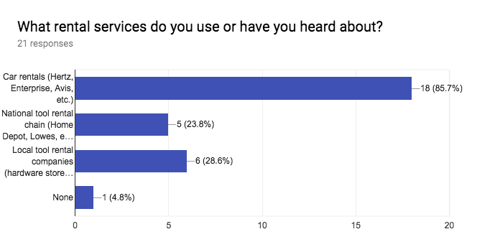

If you have rented a tool or piece of equipment before, what did you like or dislike about the experience?

* Loved renting a car and not have to worry about maintaining it.
* Had rented a DSLR camera once. Benefit was that I didn’t have to buy a DSLR as I only needed it for one small trip. There was no bad experience as such.
* There is no instant rent system.
* Only rented an Uber. It was good.
* Taking on rent - Hated the Logistics.  
  Giving on rent - Worried about damage to item.
* Some we're too pricy. Some didn't have the feasibility to home pickup/dropoff.
* I have used the services of enterprise (car rental) and I found it be extremely convenient. I am not someone who'll use a car regularly, so it's useful for me to rent a car for a day or two when I need it alone rather than spend money on buying the car, insurance and maintenance

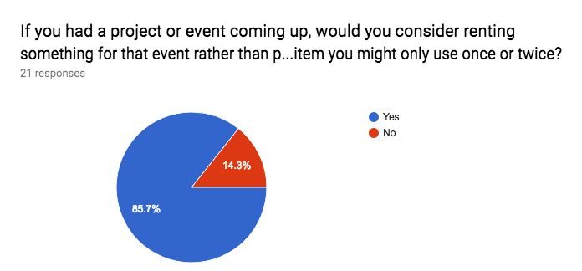

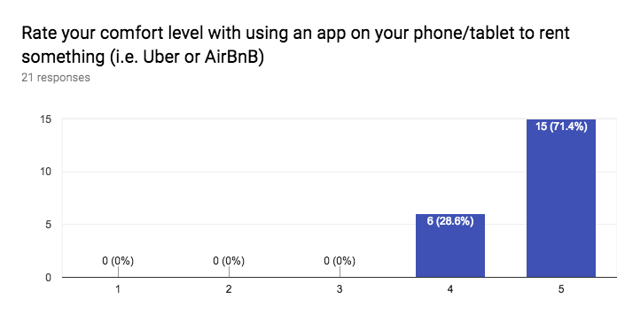

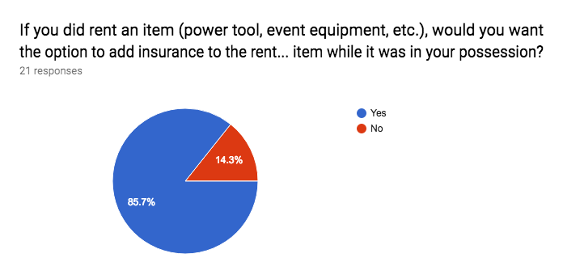

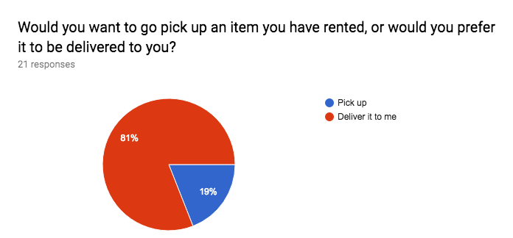

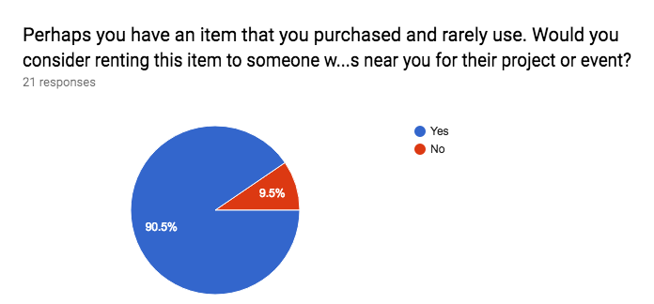

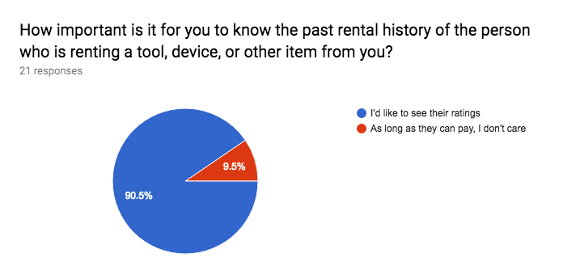

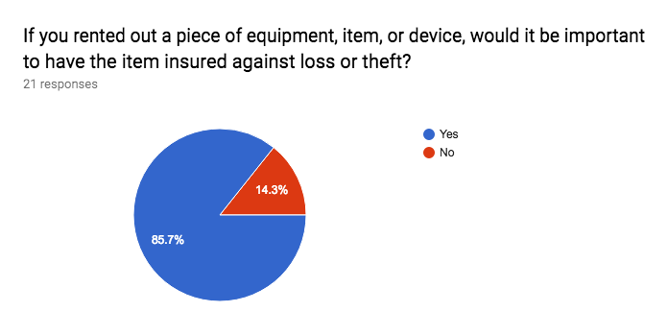

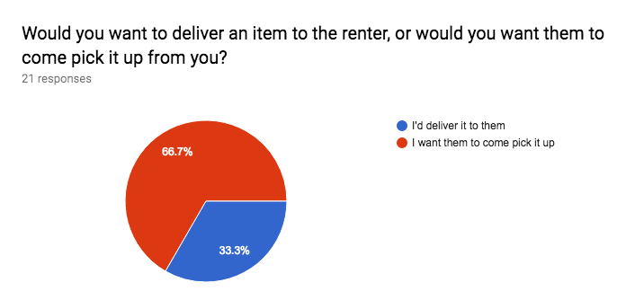

Do you have any other comments, concerns, or thoughts about the questions above? We greatly appreciate your feedback!

* I wouldn't mind delivering the item that I'm renting out, or picking up an item that I want. But these are my preferences.
* Legal documentation. Blockchain based transactions for security.